Nicolas P. Melia

26101 Country Club Blvd. Apt. 729

North Olmsted, Ohio, 44070

NightSkyCode@gmail.com

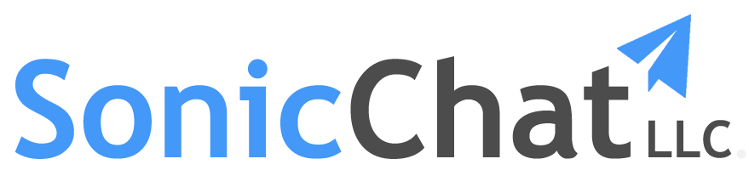

Describe the problem that your product/service addresses

When a business decides they need online customer support, setup and configuration can seem difficult. The top online customer support solutions appear to be designed for IT professionals and not the average business owner. Why does a business owner have to search through dozens of applications and spend valuable time trying to figure out how to utilize them? And, when they decide to add new support options, why should they have to modify their existing pages and seek help to include these? Furthermore, customers must now “dig” through multiple webpages to locate these features in an unfamiliar environment. Customer support should be easy for both the customer and the business owner. This is where SonicChat makes a difference.

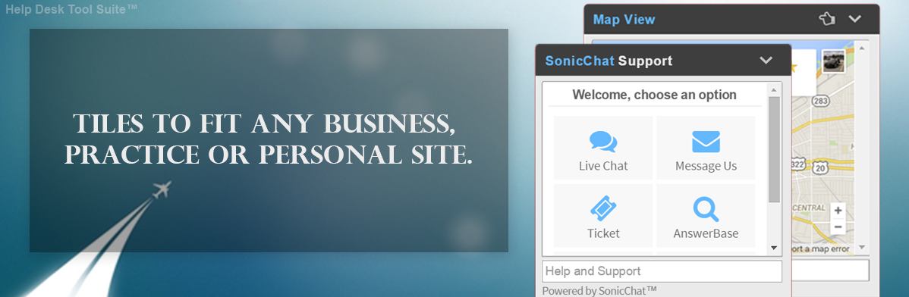

What is unique about your product/service?

SonicChat is an all-in-one, intuitive, customer support web widget that was designed to be easily implemented and extremely versatile. The idea behind SonicChat is to allow our customers to select from a variety of support tiles that best fit their business needs. Tiles are square shaped clickable icons embedded directly into the SonicChat web widget that make recognizing and navigating through support features quick and simple. When a tile is clicked on, it opens a specific functionality in the widget that customers can interact with instantly. These functions include live chat, ticket, feedback, message, appointments and more. Our customers can select from many of these tiles to include in their widget on demand without hours of set up or application configuration. When a business is ready to add or remove tiles, it’s as easy as point and click. SonicChat’s main focus is minimal set-up for powerful results, offering all of these support features in a single, yet relatable chat-box.

Describe how you validated the demand for your product or service in the market.

SonicChat fills the gap that other companies (within the industry), such as Zendesk, Freshdesk and UserVoice, leave wide open. All of these companies offer similar customer support features such as SonicChat but lack the simplicity of an inclusive solution that is not geared towards developers. Zendesk is currently the leading provider for proven, cloud-based customer service software for growing organizations. Zendesk recently become publicly traded and was valued at over 1 billion dollars. The market for customer service software grows each day, with each new business requiring different solutions based on their business needs. SonicChat fits perfectly between market leaders while offering multiple solutions in a relatable, all-in-one web widget.

Describe 3-5 critical milestones that your company needs to achieve over the next 12-18 months to advance your business.

SonicChat is attempting to take a step in a proven market with its innovative  
take on internet support solutions. SonicChat can only be as powerful as the team behind it. The first crucial milestone SonicChat needs to achieve is funding to build a small team, consisting of developers, management and mentors. The second milestone includes, releasing a minimum viable product to acquire further knowledge of customer needs to enhance and create features that are most desirable. The third milestone is gaining market penetration through beta promotion, and low cost implementation to spread awareness of SonicChat.

Is/will your business be protected by Intellectual property/trade secret/proprietary software that will give you the ability to develop a unique position in the market?

SonicChat’s model and Software solutions are not affiliated, shared or owned by anyone but myself, Nicolas Melia. SonicChat does not have existing or prior investments, cofounders or funding. All source code is proprietary and has been engineered and authored by myself (excluding license free, commercial use libraries) and is currently under my complete ownership.

Thank you,

Nicolas Melia, Founder of SonicChat.